**AWS Solutions Architect - Associate Level**

Lab Guide

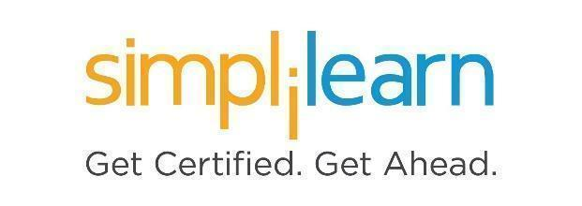

**Note: The screenshots used in Step 1 are only for your reference. Your LMS may look different depending on your course content.**

This section will guide you to:

* Use labs for executing all the demos included in this course

This lab has two subsections, namely:

1. Starting practice labs on LMS
2. Using the services required for this course in the Amazon console

**Step 1:** Starting **Practice Labs** on LMS

* Log in the Simplilearn LMS
* Go to the respective course

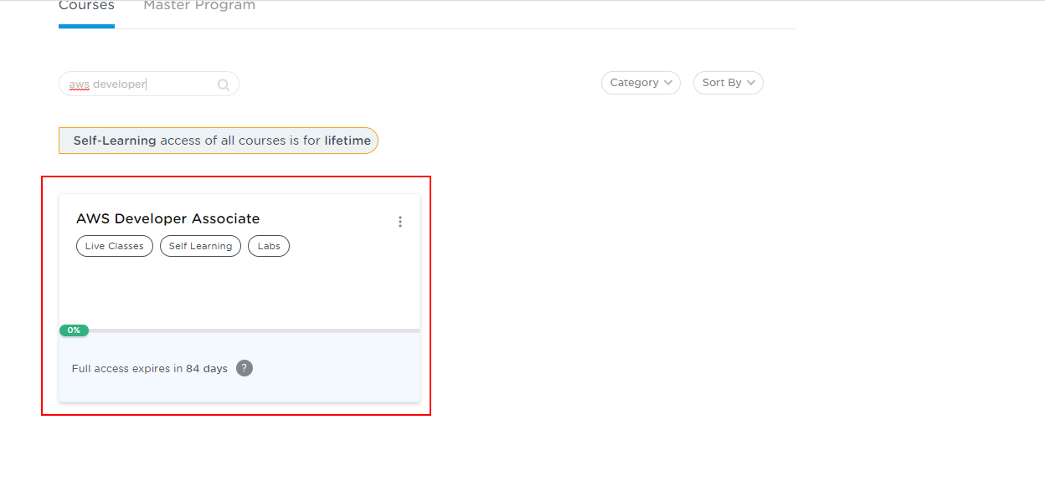

* You will see the course TOC page, click on **PRACTICE LABS**.

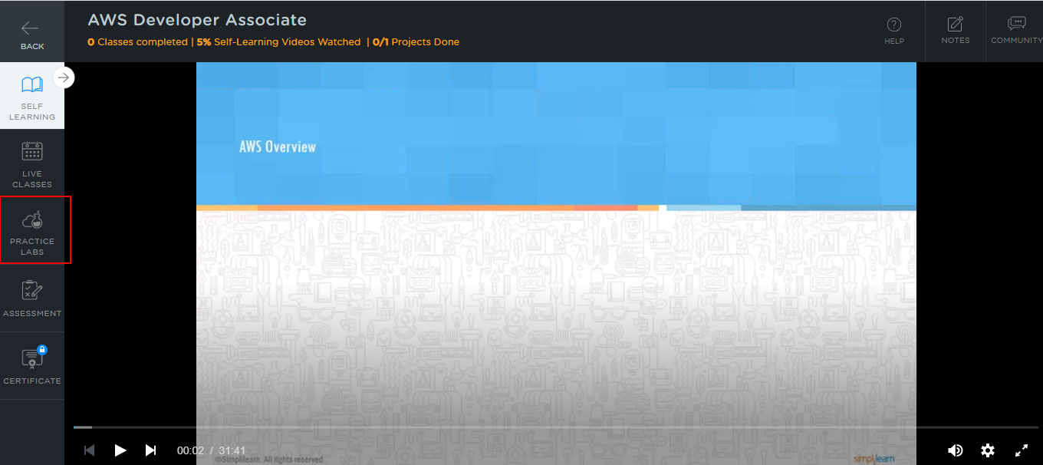

* A new window will open. Read the instructions and click on the **LAUNCH LAB** button**.** This will launch the practice labs for this course.
* In the next window, select **AWS Web Console**, and then click on the **Auth URL**, which will direct you to the Amazon console in a new browser tab

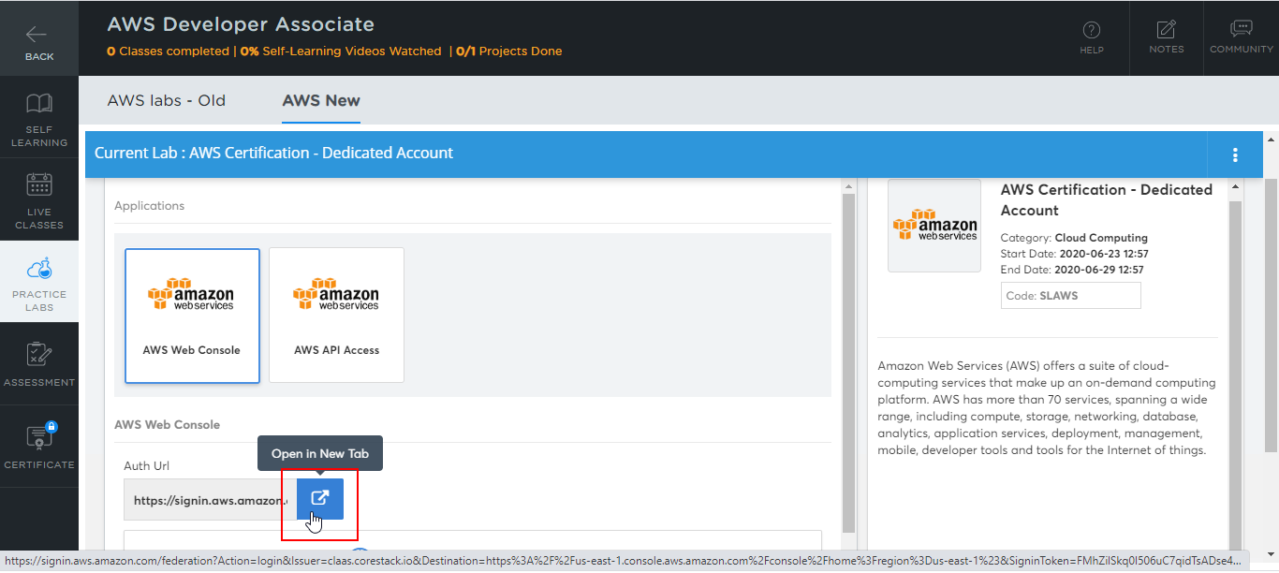

* You will be able to access the required services and resources in this console.

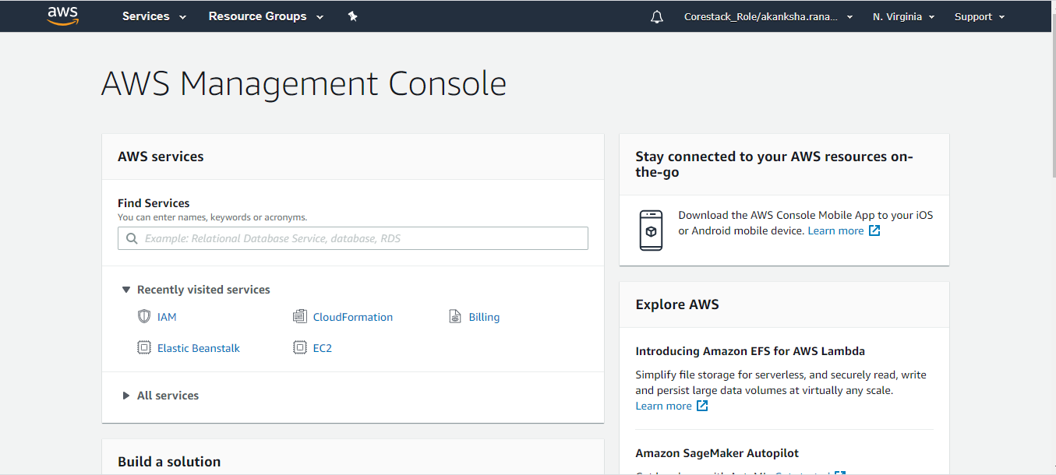

**Step 2:** Using different services in the Amazon console

* Keep in mind the following guidelines while making use of the required services in the AWS console:
  + Use **t2.micro** instance type while creating the EC2 instances
  + Set the region to **us-east-1** or **us-east-2**. Selecting any other region may result in failure for most of the actions
  + Use **Standard** or **GP2** EBS volume type and set the size **less than or equal to 30 GB**
  + Use **db.t2.micro** RDS database class while creating the RDS instances